SPECIAL NOTICE

On Tuesday, September 10, 2013, the Office of Mineral Resources on behalf of the State Mineral and Energy Board advertised in the “The Notice of Publication” for receipt of sealed bids on or before noon on Tuesday, October 8, 2013 for State Leases to be awarded upon Tract Nos. 43497 through 43541, inclusive, at its October 9, 2013 Lease Sale. Within the said advertisement were incorrect descriptions. By Virtue of this public notice, Tract Nos. 43501, 43529, 43539 and 43540, Plaquemines Parish were incorrectly advertised and are hereby corrected as follows:

TRACT 43501 - Portion of Block 1, South Pass Area, Plaquemines Parish, Louisiana
The beds and bottoms of all water bodies belonging to the State of Louisiana located in Block 1, South Pass Area, together with any present lands formed by accretion to the shoreline or islands formed therein, located in Plaquemines Parish, Louisiana, owned by and not presently under mineral lease as of October 9, 2013, from the State of Louisiana, the geographical area of which is more fully described as follows: Beginning at the Northeast corner of Block 1, South Pass Area having Coordinates of X = 2,748,750.00 and Y = 214,972.00; thence South 7,853.33 feet along the East line of said Block 1 to a point on the Louisiana Coastline, as decreed by the Supreme Court of the United States, as determined by a Special Master appointed therein, in litigation styled United States v. State of Louisiana et al No. 9 Original, in 1975, having Coordinates of X = 2,748,750.00 and Y = 207,118.67; thence Northwesterly along a straight line to a point of intersection with the Pass-A-Loutre Wildlife Management Area having Coordinates of X = 2,740,368.92 and Y = 209,558.45; thence along the boundary of said Pass-A-Loutre Wildlife Management Area the following courses: thence Northwesterly along an arc having a radius of 21,825.00 feet and a center at X = 2,725,759.55 and Y = 193,344.35 to a point having Coordinates of X = 2,739,419.00 and Y = 210,366.40; and Northwesterly along an arc having a radius of 19,550.00 feet and a center at X = 2,731,935.94 and Y = 192,305.22 to a point of intersection with the Western boundary of said Block 1 having Coordinates of X = 2,730,325.62 and Y = 211,788.78; thence North 30 degrees 27 minutes 46 seconds West 328.42 feet along the Western boundary of said Block 1 to the Southwest corner of State Lease No. 988, as amended, having Coordinates of X = 2,730,159.12 and Y = 212,071.87; thence along the boundary of said State Lease No. 988, as amended, the following courses: North 77 degrees 14 minutes 29 seconds East 308.50 feet to a point having Coordinates of X = 2,730,460.00 and Y = 212,140.00 and North 07 degrees 08 minutes 42 seconds East 2,854.16 feet to a point on the North line of said Block 1 having Coordinates of X = 2,730,815.00 and Y = 214,972.00; thence East 17,935.00 feet along the North line of said Block 1 to the point of beginning, LESS AND EXCEPT that portion that falls inside of the Pass-A-Loutre Wildlife Management Area, that may lie within the above described tract, containing approximately 2,101.03 acres, all as more particularly outlined on a plat on file in the Office of Mineral Resources, Department of Natural Resources. All bearings, distances and coordinates are based on Louisiana Coordinate System of 1927, (North or South Zone).

NOTE: The above description of the Tract nominated for lease has been provided and corrected, where required, exclusively by the nomination party. Any mineral lease selected from this Tract and awarded by the Louisiana State Mineral and Energy Board shall be without warranty of any kind, either express, implied, or statutory, including, but not limited to, the implied warranties of merchantability and fitness for a particular purpose. Should the mineral lease awarded by the Louisiana State Mineral and Energy Board be subsequently modified, cancelled or abrogated due to the existence of conflicting leases, operating agreements, private claims or other future obligations or conditions which may affect all or any portion of the leased Tract, it shall not relieve the Lessee of the obligation to pay any bonus due thereon to the Louisiana State Mineral and Energy Board, nor shall the Louisiana State Mineral and Energy Board be obligated to refund any consideration paid by the Lessor prior to such modification, cancellation, or abrogation, including, but not limited to, bonuses, rentals and royalties.

NOTE: The State of Louisiana does hereby reserve, and this lease shall be subject to, the imprescriptible right of surface use in the nature of a servitude in favor of the Department of Natural Resources, including its Offices and Commissions, for the sole purpose of implementing, constructing, servicing and maintaining approved coastal zone management and/or restoration projects. Utilization of any and all rights derived under this lease by the mineral lessee, its agents, successors or assigns, shall not interfere with nor hinder the reasonable surface use by the Department of Natural Resources, its Offices or Commissions, as herein above reserved.

NOTE: This tract is located in an area designated by the Louisiana Legislature or the Wildlife and Fisheries Commission as a Public Oyster Seed Ground, Reservation, or area of Calcasieu or Sabine Lake. Proposed projects occurring in these areas will be evaluated on a case by case basis by Louisiana Department of Wildlife & Fisheries. Modifications to proposed project features including, but not limited to, access routes, well sites, flowlines, and appurtenant structures maybe required by the Louisiana Department of Wildlife and Fisheries. In addition, compensatory mitigation will be required to offset unavoidable habitat impacts.

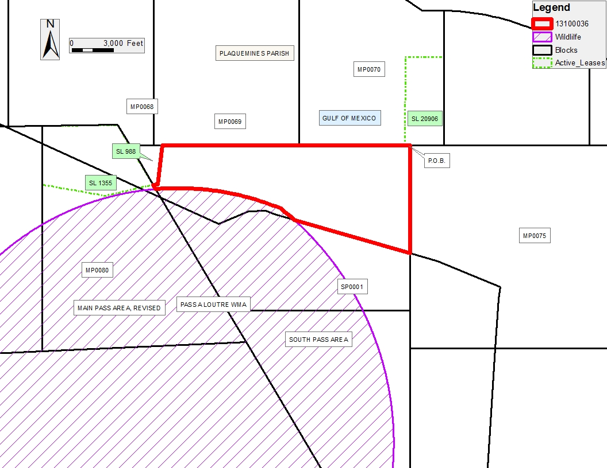

TRACT 43529 - Portion of Block 1, South Pass Area, Plaquemines Parish, Louisiana
All of the lands now or formerly constituting the beds and bottoms of all water bodies of every nature and description as to which title is vested in the State of Louisiana, together with all islands arising therein and other lands formed by accretion or by reliction, where allowed by law, excepting tax adjudicated lands, and not presently under mineral lease on October 9, 2013, situated in Plaquemines Parish, Louisiana, and more particularly described as follows: Beginning at the Southeast corner of Block 1, South Pass Area having Coordinates of X = 2,748,750.00 and Y = 202,972.00; thence West 3,403.74 feet along the boundary of said Block 1 to a point of intersection with the boundary of the Pass-A-Loutre Wildlife Management Area having Coordinates of X = 2,745,346.26 and Y = 202,972.00; thence along the boundary of said Pass-A-Loutre Wildlife Management Area, Northwesterly along an arc having a radius of 21,825.00 feet and a center at X = 2,725,759.55 and Y = 193,344.35 to a point of intersection with the Louisiana Coastline, as decreed by the Supreme Court of the United States, as determined by a Special Master appointed therein, in litigation styled United States v. State of Louisiana et al No. 9 Original, in 1975, having Coordinates of X = 2,740,368.92 and Y = 209,558.45; thence Southeasterly along said Coastline to a point on the East line of said Block 1 having Coordinates of X = 2,748,750.00 and Y = 207,118.67; thence South 4,146.67 feet along the East line of said Block 1 to the point of beginning, LESS AND EXCEPT that portion that falls inside of the Pass-A-Loutre Wildlife Management Area, that may lie within the above described tract, containing approximately 606.39 acres, all as more particularly outlined on a plat on file in the Office of Mineral Resources, Department of Natural Resources. All bearings, distances and coordinates are based on Louisiana Coordinate System of 1927, (North or South Zone), where applicable.

NOTE: The above description of the Tract nominated for lease has been provided and corrected, where required, exclusively by the nomination party. Any mineral lease selected from this Tract and awarded by the Louisiana State Mineral and Energy Board shall be without warranty of any kind, either express, implied, or statutory, including, but not limited to, the implied warranties of merchantability and fitness for a particular purpose. Should the mineral lease awarded by the Louisiana State Mineral and Energy Board be subsequently modified, cancelled or abrogated due to the existence of conflicting leases, operating agreements, private claims or other future obligations or conditions which may affect all or any portion of the leased Tract, it shall not relieve the Lessee of the obligation to pay any bonus due thereon to the Louisiana State Mineral and Energy Board, nor shall the Louisiana State Mineral and Energy Board be obligated to refund any consideration paid by the Lessor prior to such modification, cancellation, or abrogation, including, but not limited to, bonuses, rentals and royalties.

NOTE: The State of Louisiana does hereby reserve, and this lease shall be subject to, the imprescriptible right of surface use in the nature of a servitude in favor of the Department of Natural Resources, including its Offices and Commissions, for the sole purpose of implementing, constructing, servicing and maintaining approved coastal zone management and/or restoration projects. Utilization of any and all rights derived under this lease by the mineral lessee, its agents, successors or assigns, shall not interfere with nor hinder the reasonable surface use by the Department of Natural Resources, its Offices or Commissions, as herein above reserved.

NOTE: This tract is located in an area designated by the Louisiana Legislature or the Wildlife and Fisheries Commission as a Public Oyster Seed Ground, Reservation, or area of Calcasieu or Sabine Lake. Proposed projects occurring in these areas will be evaluated on a case by case basis by Louisiana Department of Wildlife & Fisheries. Modifications to proposed project features including, but not limited to, access routes, well sites, flowlines, and appurtenant structures maybe required by the Louisiana Department of Wildlife and Fisheries. In addition, compensatory mitigation will be required to offset unavoidable habitat impacts.

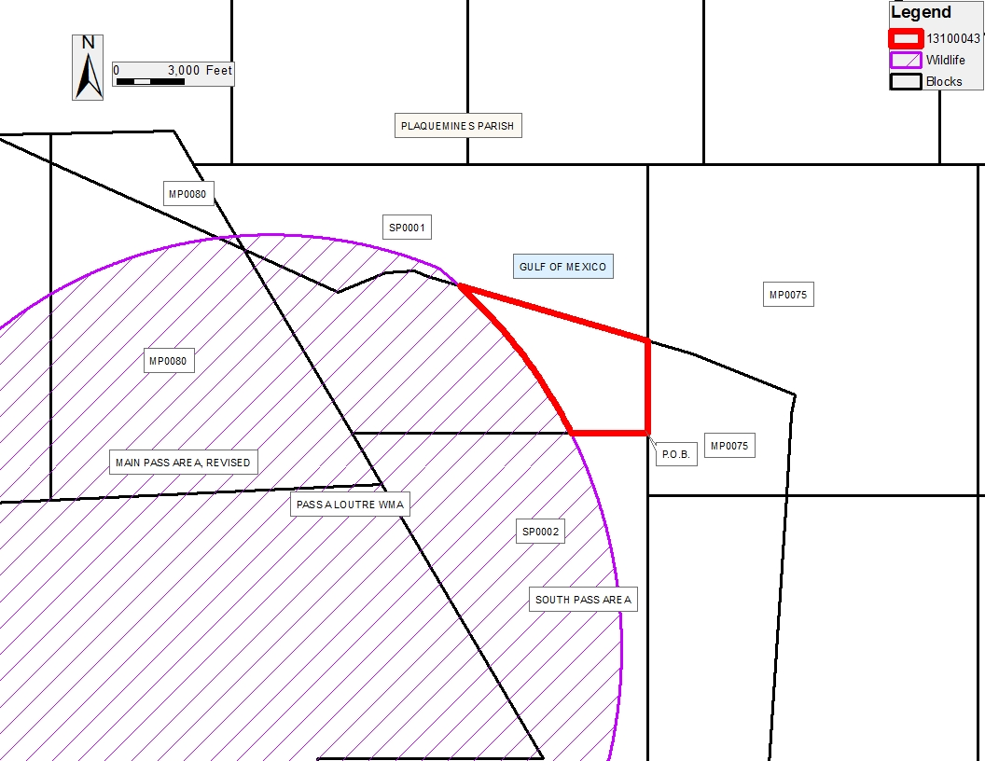

TRACT 43539 - Plaquemines Parish, Louisiana
All State owned lands and water bottoms located within the boundaries of the Pass-A-Loutre Wildlife Management Area as defined by the Department of Wildlife and Fisheries incorporating a title opinion from the Office of the Governor dated August 3, 1998, not presently under mineral lease by the State of Louisiana on October 9, 2013, all as set forth following: Beginning at a point within the Pass-A-Loutre Wildlife Management Area having Coordinates of X = 2,730,675.41 and Y = 211,194.08; thence North 30 degrees 27 minutes 46 seconds West 689.95 feet to a point on the Northern boundary of said Pass-A-Loutre Wildlife Management Area having Coordinates of X = 2,730,325.62 and Y = 211,788.78; thence along the boundary of said Pass A Loutre Wildlife Management Area the following courses: Southeasterly along an arc having a radius of 19,550.00 feet and a center at X = 2,731,935.94 and Y = 192,305.22 to a point having Coordinates of X = 2,739,419.00 and Y = 210,366.40; and Southeasterly along an arc having a radius of 21,825.00 feet and a center at X = 2,725,759.55 and Y = 193,344.35 to a point having Coordinates of X = 2,740,368.92 and Y = 202,558.45; thence North 73 degrees 46 minutes 10 seconds West 1,490.32 feet to a point having Coordinates of X = 2,738,938.00 and Y = 209,975.00; thence North 67 degrees 34 minutes 41 seconds West 668.54 feet to a point having Coordinates of X = 2,738,320.00 and Y = 210,230.00; thence South 86 degrees 34 minutes 48 seconds West 1,257.24 feet to a point having Coordinates of X = 2,737,065.00 and Y = 210,155.00; thence South 67 degrees 52 minutes 48 seconds West 2,337.01 feet to a point having Coordinates of X = 2,734,900.00 and Y = 209,275.00; thence North 65 degrees 34 minutes 10 seconds West 4,640.04 feet to the point of beginning, LESS AND EXCEPT that portion that falls outside of the Pass-A-Loutre Wildlife Management Area, that may lie within the above described tract, and LESS AND EXCEPT any privately owned land that may be located within the above described Tract, if any, said tract containing approximately 282.01 acres, all as more particularly outlined on a plat on file in the Office of Mineral Resources, Department of Natural Resources. All bearings, distances and coordinates are based on Louisiana Coordinate System of 1927, (South Zone).

NOTE: The above description of the Tract nominated for lease has been provided and corrected, where required, exclusively by the nomination party. Any mineral lease selected from this Tract and awarded by the Louisiana State Mineral and Energy Board shall be without warranty of any kind, either express, implied, or statutory, including, but not limited to, the implied warranties of merchantability and fitness for a particular purpose. Should the mineral lease awarded by the Louisiana State Mineral and Energy Board be subsequently modified, cancelled or abrogated due to the existence of conflicting leases, operating agreements, private claims or other future obligations or conditions which may affect all or any portion of the leased Tract, it shall not relieve the Lessee of the obligation to pay any bonus due thereon to the Louisiana State Mineral and Energy Board, nor shall the Louisiana State Mineral and Energy Board be obligated to refund any consideration paid by the Lessor prior to such modification, cancellation, or abrogation, including, but not limited to, bonuses, rentals and royalties.

NOTE: The mineral lease is located in the Pass-A-Loutre WMA under the jurisdiction of the Louisiana Department of Wildlife and Fisheries which has promulgated rules and regulations for the protection of game and wildlife on the aforesaid Tract and, therefore, shall be subject to said rules and regulations, a copy of which shall be attached to the mineral lease. In addition to the specific rules and regulations applicable, the following shall apply regarding operations under this mineral lease:

NOTE: No activities will be allowed without written authorization from the Louisiana Department of Wildlife and Fisheries.

NOTE: Proposed projects will be evaluated on a case by case basis. Modifications to proposed project features including but not limited to access routes, spoil placement, well sites, flowlines and appurtenant structures may be required by the Department of Wildlife and Fisheries.

NOTE: Compliance with the said WMA regulations will be required unless otherwise specified by the Department of Wildlife and Fisheries.

NOTE: Compensatory mitigation will be required to offset unavoidable wetland impacts.

NOTE: Removal of all structures, facilities and equipment will be required within 120 days of abandonment unless otherwise agreed to in writing by the Louisiana Department of Wildlife and Fisheries.

NOTE: No activities will be allowed during the hunting season unless approved by the Department.

NOTE: Prior to submitting applications for wetland permits to Federal and State permitting agencies the leaseholder shall coordinate project details with the Department of Wildlife and Fisheries. Contact person for the Department will be Mike Windham at (504) 284-5268.

NOTE: The Department of Wildlife & Fisheries will require a minimum bonus of $350 per acre and a minimum royalty of 25%.

NOTE: The State of Louisiana does hereby reserve, and this lease shall be subject to, the imprescriptible right of surface use in the nature of a servitude in favor of the Department of Natural Resources, including its Offices and Commissions, for the sole purpose of implementing, constructing, servicing and maintaining approved coastal zone management and/or restoration projects. Utilization of any and all rights derived under this lease by the mineral lessee, its agents, successors or assigns, shall not interfere with nor hinder the reasonable surface use by the Department of Natural Resources, its Offices or Commissions, as herein above reserved.

NOTE: This tract is located in an area designated by the Louisiana Legislature or the Wildlife and Fisheries Commission as a Public Oyster Seed Ground, Reservation, or area of Calcasieu or Sabine Lake. Proposed projects occurring in these areas will be evaluated on a case by case basis by Louisiana Department of Wildlife & Fisheries. Modifications to proposed project features including, but not limited to, access routes, well sites, flowlines, and appurtenant structures maybe required by the Louisiana Department of Wildlife and Fisheries. In addition, compensatory mitigation will be required to offset unavoidable habitat impacts.

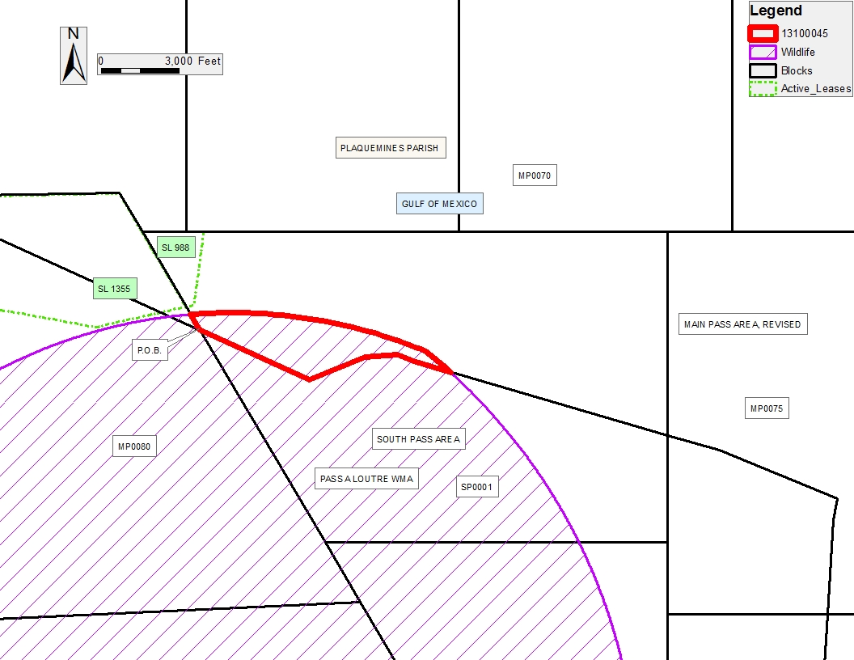

TRACT 43540 - Plaquemines Parish, Louisiana
All State owned lands and water bottoms located within the boundaries of the Pass-A-Loutre Wildlife Management Area as defined by the Department of Wildlife and Fisheries incorporating a title opinion from the Office of the Governor dated August 3, 1998, not presently under mineral lease by the State of Louisiana on October 9, 2013, all as set forth following: Beginning at a point within the Pass-A-Loutre Wildlife Management Area having Coordinates of X = 2,735,511.40 and Y = 202,972.00; thence North 30 degrees 27 minutes 46 seconds West 9,538.83 feet to a point having Coordinates of X = 2,730,675.41 and Y = 211,194.08; thence South 65 degrees 34 minutes 10 seconds East 4,640.04 feet to a point having Coordinates of X = 2,734,900.00 and Y = 209,275.00; thence North 67 degrees 52 minutes 48 seconds East 2,337.01 feet to a point having Coordinates of X = 2,737,065.00 and Y = 210,155.00; thence North 86 degrees 34 minutes 48 seconds East 1,257.24 feet to a point having Coordinates of X = 2,738,320.00 and Y = 210,230.00; thence South 67 degrees 34 minutes 41 seconds East 668.54 feet to a point having Coordinates of X = 2,738,938.00 and Y = 209,975.00; thence South 73 degrees 46 minutes 10 seconds East 1,490.32 feet to a point on the boundary of said Pass-A-Loutre Wildlife Management Area having Coordinates of X = 2,740,368.92 and Y = 209,558.45; thence Southeasterly along an arc having a radius of 21,825.00 feet and a center at X = 2,725,759.55 and Y = 193,344.35 to a point having Coordinates of X = 2,745,346.26 and Y = 202,972.00; thence West 9,834.86 feet to the point of beginning, LESS AND EXCEPT that portion that falls outside of the Pass-A-Loutre Wildlife Management Area, that may lie within the above described tract, and LESS AND EXCEPT any privately owned land that may be located within the above described Tract, if any, said tract containing approximately 1,541.63 acres, all as more particularly outlined on a plat on file in the Office of Mineral Resources, Department of Natural Resources. All bearings, distances and coordinates are based on Louisiana Coordinate System of 1927, (South Zone).

NOTE: The above description of the Tract nominated for lease has been provided and corrected, where required, exclusively by the nomination party. Any mineral lease selected from this Tract and awarded by the Louisiana State Mineral and Energy Board shall be without warranty of any kind, either express, implied, or statutory, including, but not limited to, the implied warranties of merchantability and fitness for a particular purpose. Should the mineral lease awarded by the Louisiana State Mineral and Energy Board be subsequently modified, cancelled or abrogated due to the existence of conflicting leases, operating agreements, private claims or other future obligations or conditions which may affect all or any portion of the leased Tract, it shall not relieve the Lessee of the obligation to pay any bonus due thereon to the Louisiana State Mineral and Energy Board, nor shall the Louisiana State Mineral and Energy Board be obligated to refund any consideration paid by the Lessor prior to such modification, cancellation, or abrogation, including, but not limited to, bonuses, rentals and royalties.

NOTE: The mineral lease is located in the Pass-A-Loutre WMA under the jurisdiction of the Louisiana Department of Wildlife and Fisheries which has promulgated rules and regulations for the protection of game and wildlife on the aforesaid Tract and, therefore, shall be subject to said rules and regulations, a copy of which shall be attached to the mineral lease. In addition to the specific rules and regulations applicable, the following shall apply regarding operations under this mineral lease:

NOTE: No activities will be allowed without written authorization from the Louisiana Department of Wildlife and Fisheries.

NOTE: Proposed projects will be evaluated on a case by case basis. Modifications to proposed project features including but not limited to access routes, spoil placement, well sites, flowlines and appurtenant structures may be required by the Department of Wildlife and Fisheries.

NOTE: Compliance with the said WMA regulations will be required unless otherwise specified by the Department of Wildlife and Fisheries.

NOTE: Compensatory mitigation will be required to offset unavoidable wetland impacts.

NOTE: Removal of all structures, facilities and equipment will be required within 120 days of abandonment unless otherwise agreed to in writing by the Louisiana Department of Wildlife and Fisheries.

NOTE: No activities will be allowed during the hunting season unless approved by the Department.

NOTE: Prior to submitting applications for wetland permits to Federal and State permitting agencies the leaseholder shall coordinate project details with the Department of Wildlife and Fisheries. Contact person for the Department will be Mike Windham at (504) 284-5268.

NOTE: The Department of Wildlife & Fisheries will require a minimum bonus of $350 per acre and a minimum royalty of 25%

NOTE: The State of Louisiana does hereby reserve, and this lease shall be subject to, the imprescriptible right of surface use in the nature of a servitude in favor of the Department of Natural Resources, including its Offices and Commissions, for the sole purpose of implementing, constructing, servicing and maintaining approved coastal zone management and/or restoration projects. Utilization of any and all rights derived under this lease by the mineral lessee, its agents, successors or assigns, shall not interfere with nor hinder the reasonable surface use by the Department of Natural Resources, its Offices or Commissions, as herein above reserved.

NOTE: This tract is located in an area designated by the Louisiana Legislature or the Wildlife and Fisheries Commission as a Public Oyster Seed Ground, Reservation, or area of Calcasieu or Sabine Lake. Proposed projects occurring in these areas will be evaluated on a case by case basis by Louisiana Department of Wildlife & Fisheries. Modifications to proposed project features including, but not limited to, access routes, well sites, flowlines, and appurtenant structures maybe required by the Louisiana Department of Wildlife and Fisheries. In addition, compensatory mitigation will be required to offset unavoidable habitat impacts.

